**CODE**

**import tkinter**

**import cv2**

**import PIL.Image, PIL.ImageTk**

**from functools import partial**

**import threading # to load another image at samae rate**

**import time**

**import imutils**

**SET_WIDTH = 600**

**SET_HEIGHT = 500**

**stream = cv2.VideoCapture("clip.mp4")**

**flag = True**

**def play(speed):**

**global flag**

**print(f"You clicked on play. Speed is {speed}")**

**# Play the video in reverse mode**

**frame1 = stream.get(cv2.CAP_PROP_POS_FRAMES)**

**stream.set(cv2.CAP_PROP_POS_FRAMES, frame1 + speed)**

**grabbed, frame = stream.read()**

**if not grabbed:**

**exit()**

**frame = imutils.resize(frame, width=SET_WIDTH, height=SET_HEIGHT)**

**frame = PIL.ImageTk.PhotoImage(image = PIL.Image.fromarray(frame))**

**canvas.image = frame**

**canvas.create_image(0,0, image=frame, anchor=tkinter.NW)**

**if flag:**

**canvas.create_text(134, 26, fill="red", font="Times 26 bold", text="Decision Pending")**

**flag = not flag**

**def pending(decision):**

**'''**

**1. Display Decision pending image**

**2 wait for second**

**3 display sponsor image**

**4 wait for 1.5 second**

**5 Display out/notout image'''**

**frame = cv2.cvtColor(cv2.imread('decision_pending.jpg'), cv2.COLOR_BGR2RGB)**

**frame = imutils.resize(frame, width = SET_WIDTH , height = SET_HEIGHT)**

**frame = PIL.ImageTk.PhotoImage(image =PIL.Image.fromarray( frame))**

**canvas.image = frame**

**canvas.create_image(0, 0 , image=frame , anchor = tkinter.NW)**

**time.sleep(1)**

**frame = cv2.cvtColor(cv2.imread('Sponsor.jpg'), cv2.COLOR_BGR2RGB)**

**frame = imutils.resize(frame, width = SET_WIDTH , height = SET_HEIGHT)**

**frame = PIL.ImageTk.PhotoImage(image =PIL.Image.fromarray( frame))**

**canvas.image = frame**

**canvas.create_image(0, 0 , image=frame , anchor = tkinter.NW)**

**time.sleep(2.5)**

**if decision == 'out':**

**decisionImg = "out.jpg"**

**else:**

**decisionImg = "Not_out.jpg"**

**frame = cv2.cvtColor(cv2.imread(decisionImg), cv2.COLOR_BGR2RGB)**

**frame = imutils.resize(frame, width=SET_WIDTH, height=SET_HEIGHT)**

**frame = PIL.ImageTk.PhotoImage(image=PIL.Image.fromarray(frame))**

**canvas.image = frame**

**canvas.create_image(0,0, image=frame, anchor=tkinter.NW)**

**def out():**

**thread = threading.Thread(target=pending, args=("out",))**

**thread.daemon = 1**

**thread.start()**

**print("Player is out")**

**def not_out():**

**thread = threading.Thread(target=pending, args=("not out",))**

**thread.daemon = 1**

**thread.start()**

**print("Player is not out")**

**window = tkinter.Toplevel() # to make GUI window**

**window.title(" Third Umpire Decision Review System by Deepak")**

**canvas = tkinter.Canvas(window, width = SET_WIDTH, height= SET_HEIGHT)**

**cv_img = cv2.cvtColor(cv2.imread("Kotla.jpg"), cv2.COLOR_BGR2RGB)**

**cv_img = imutils.resize(cv_img, width =SET_WIDTH , height = SET_HEIGHT)**

**#to set image ingui**

**photo = PIL.ImageTk.PhotoImage(image=PIL.Image.fromarray(cv_img))**

**#to work allthis thing we need to pack in canvas we r packing in canvas**

**image_on_canvas = canvas.create_image(0, 0, ancho=tkinter.NW, image=photo)**

**canvas.pack()**

**#BUTTONS TO CONTRO PLAY BACK**

**btn = tkinter.Button(window, text="<<Previous (fast)", width=50,command = partial(play, -25))**

**btn.pack()**

**btn = tkinter.Button(window, text="<<Previous (slow)",width=50, command = partial(play, -2))**

**btn.pack()**

**btn = tkinter.Button(window, text="GiveOut",width=50, command = out)**

**btn.pack()**

**btn = tkinter.Button(window, text="Give Not OUT",width=50, command = not_out)**

**btn.pack()**

**btn = tkinter.Button(window, text="Next (fast)>>",width=50, command = partial(play, 25))**

**btn.pack()**

**btn = tkinter.Button(window, text="Next (slow)>>",width=50, command = partial(play, 2))**

**btn.pack()**

**window.mainloop()**

**OUTPUTS**

**Main Screen Menu which shows:**

1. **Previous(fast)**
2. **Precious(slow)**
3. **Give Out**
4. **Give Not Out**
5. **Next (fast)**
6. **Next (slow)**

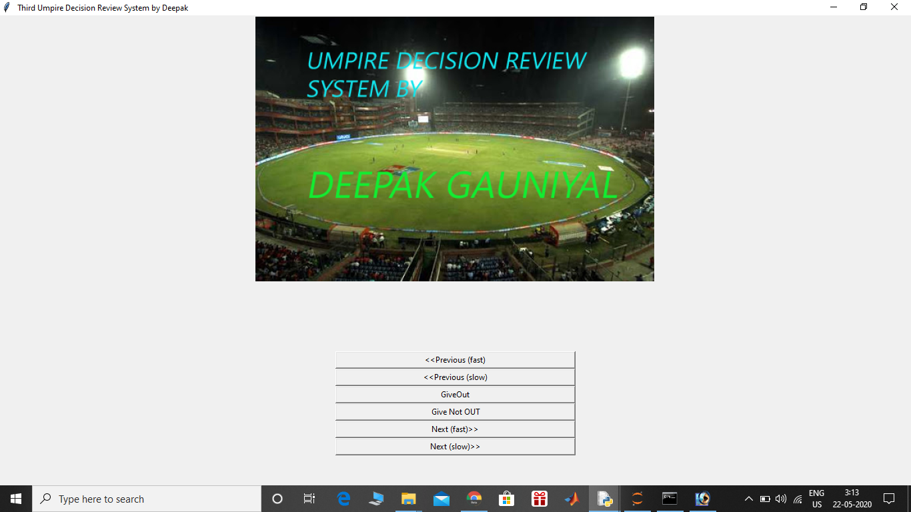

**This is Starting of Video**

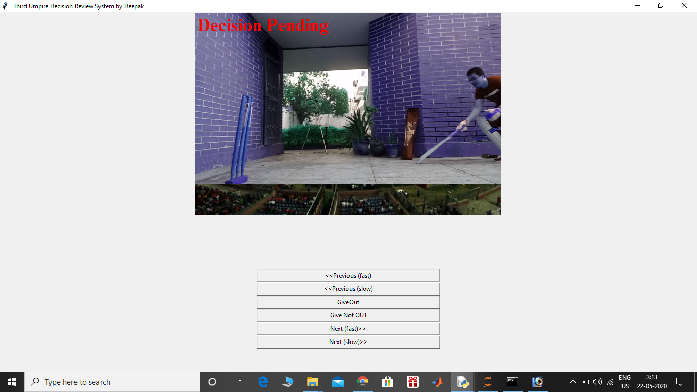

**So now we will implement our First button that is Next(Fast)**

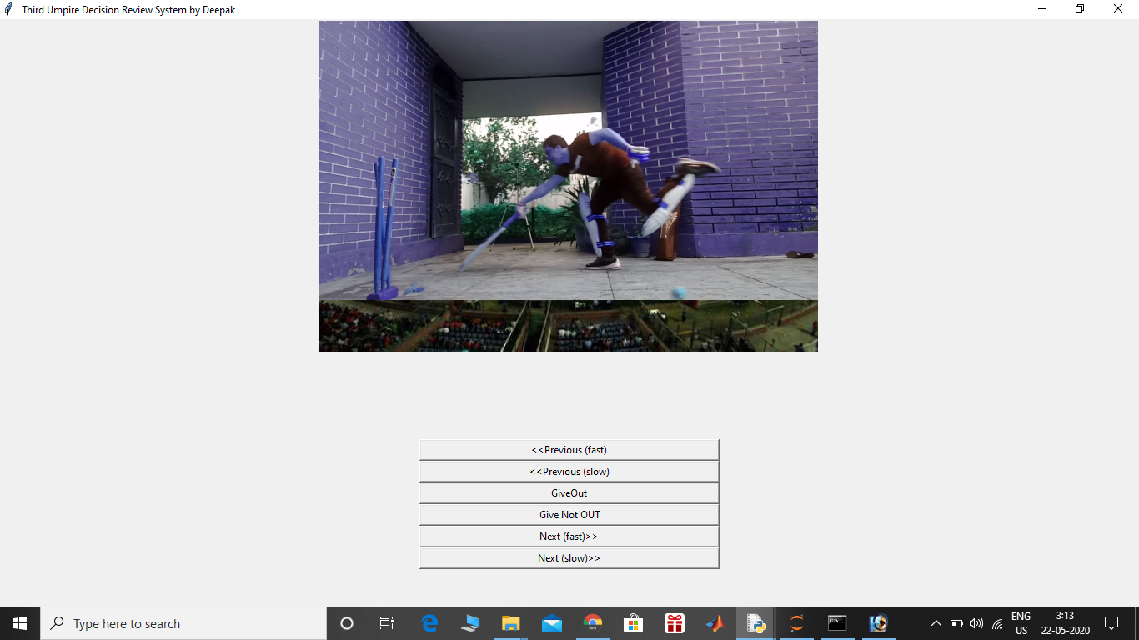

**You can see how much batsmen have travelled when I did Next(fast) that is we are moving ahead in video with good speed. If I compare this frame with start of video…we cannot conclude anything whether he is out or not. So let we see a much slower Frame**

**Here now we will show different Frames of Next(Slow)**

**Slow 1 Slow 2**

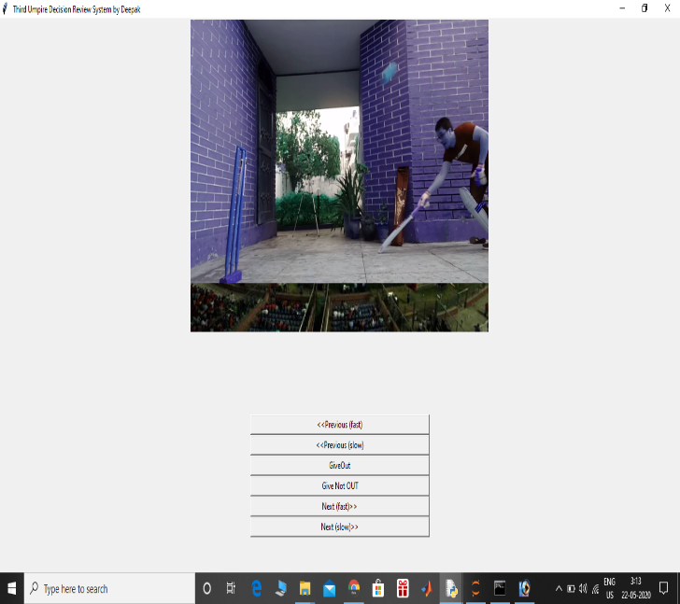 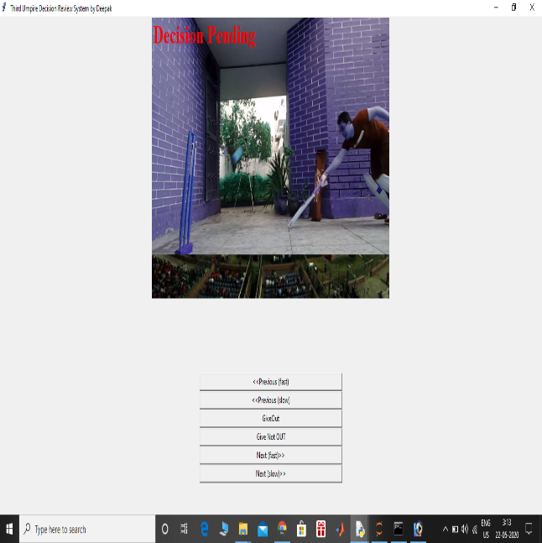

**Slow 3 Slow 4**

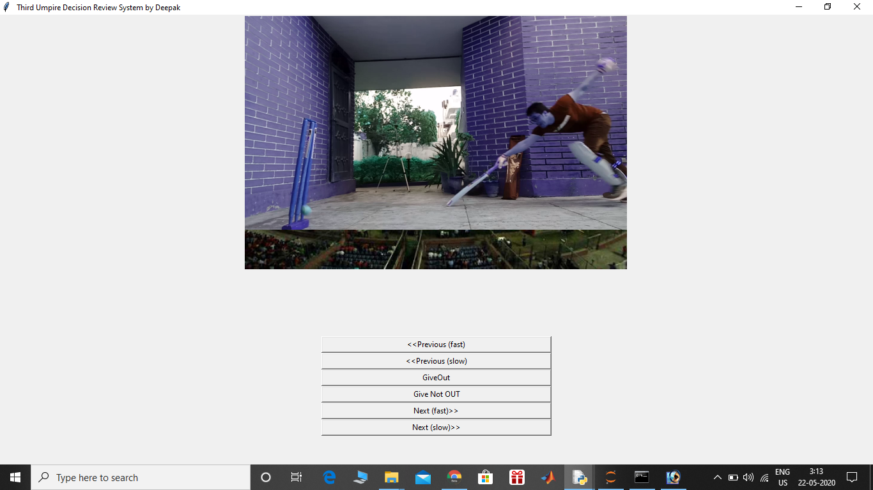 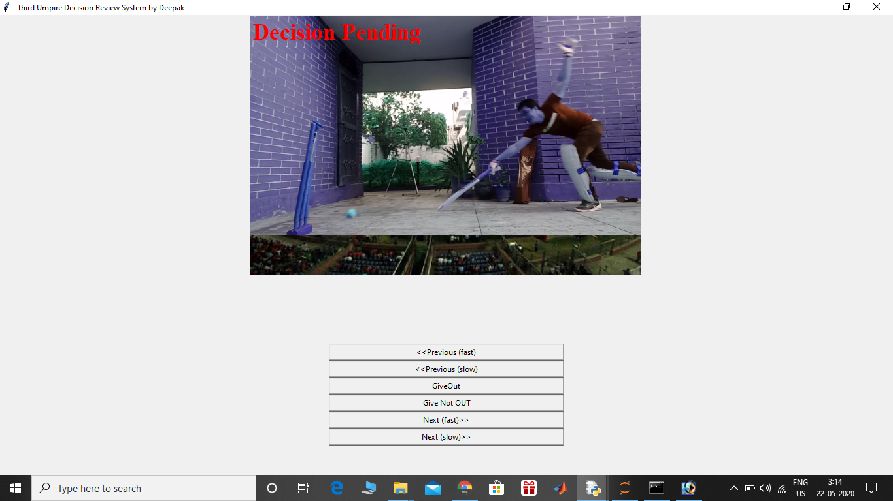

**Slow 5**

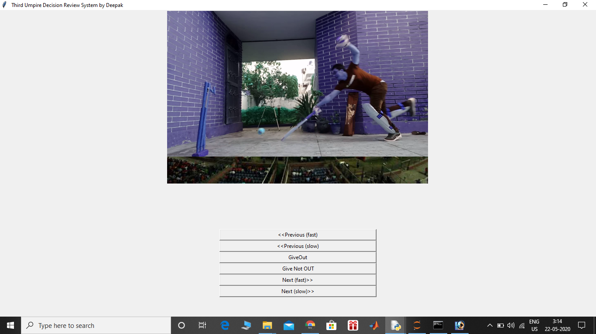

**Slow 5 is the moment when bails are just got off. Also slow 3 is the case where batsman just passes the crease and till than ball haven’t reached the wickets. But Umpire wants to see it once again. So let we use previous functionality.**

**This is End of Video**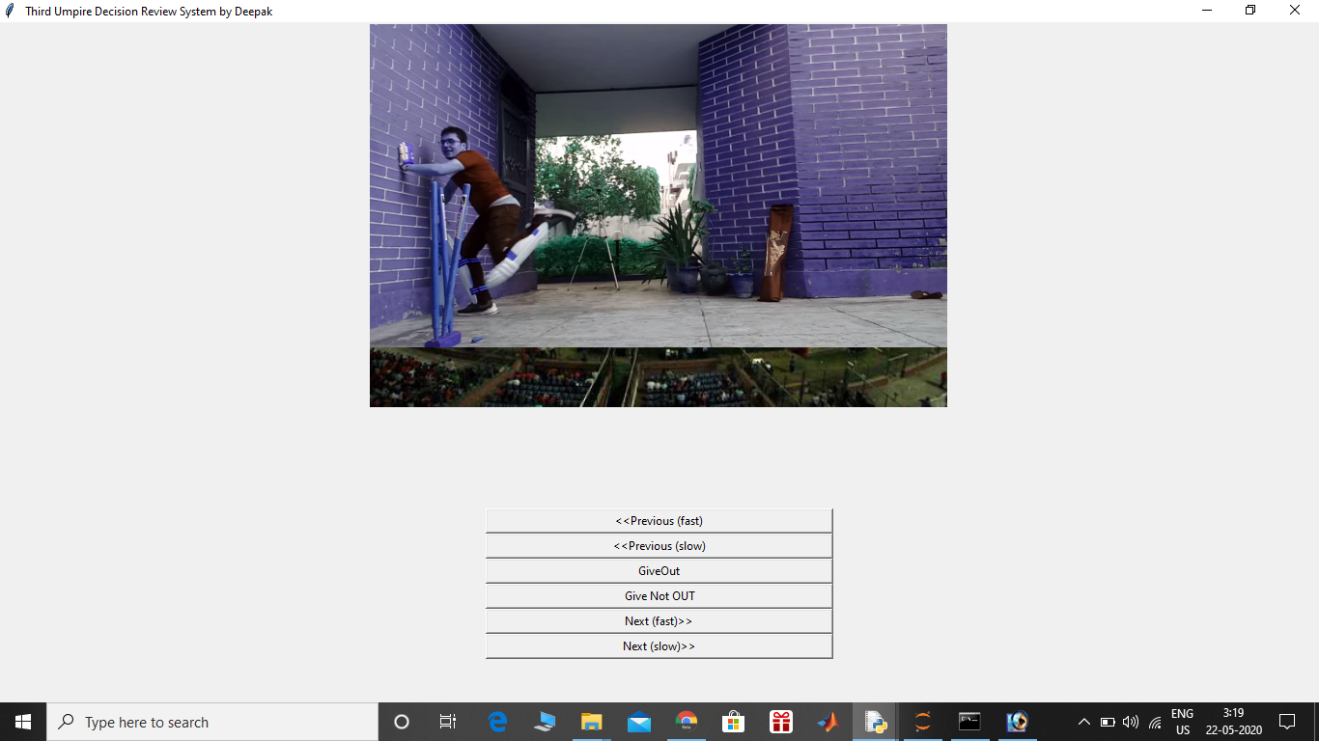

**Now let us check that Previous functionality too. So let us Implement Previous (fast) first.**

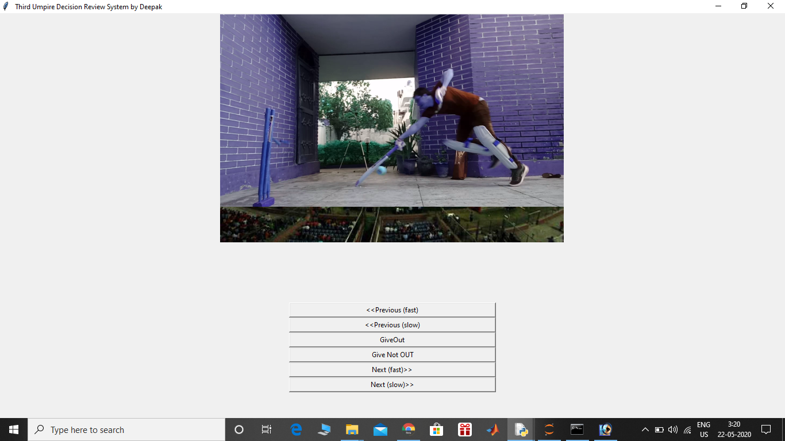

**So one can easily see the difference by comparing it with “End of video” that with what speed this video goes back.**

**Now we will see implementation of Previous (Slow)**

**Slow 1 Slow 2**

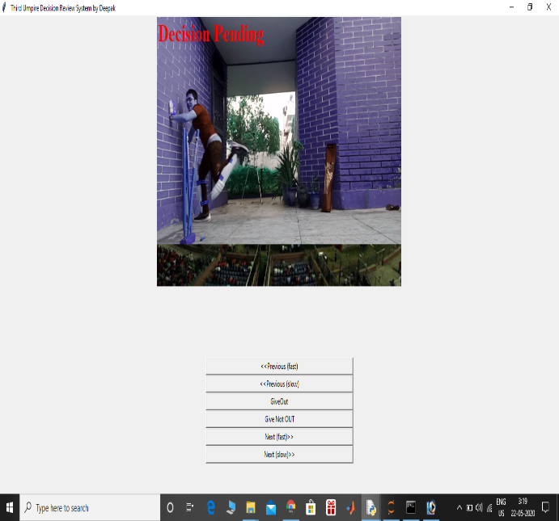 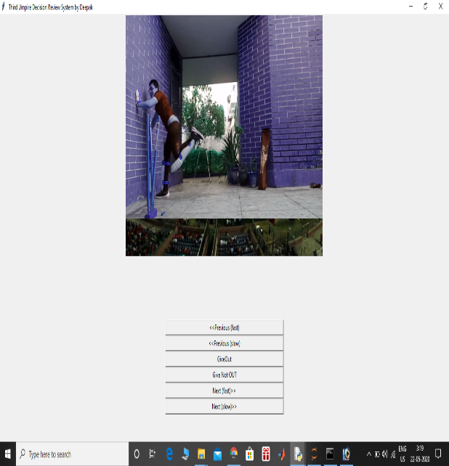

**Slow 3 Slow 4**

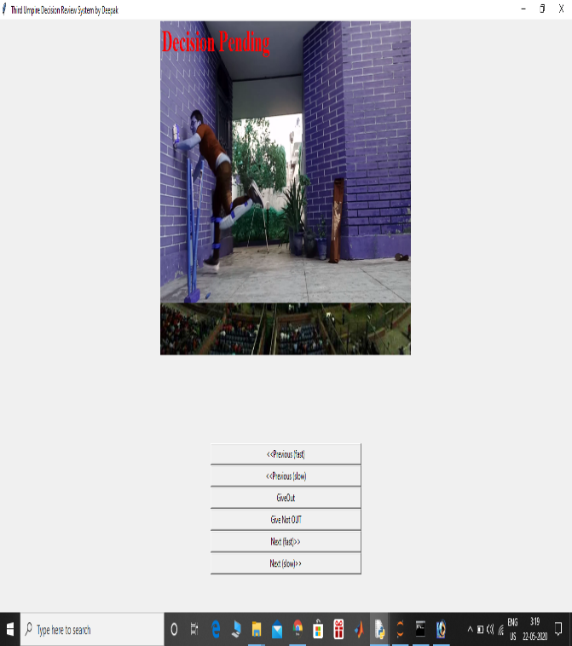 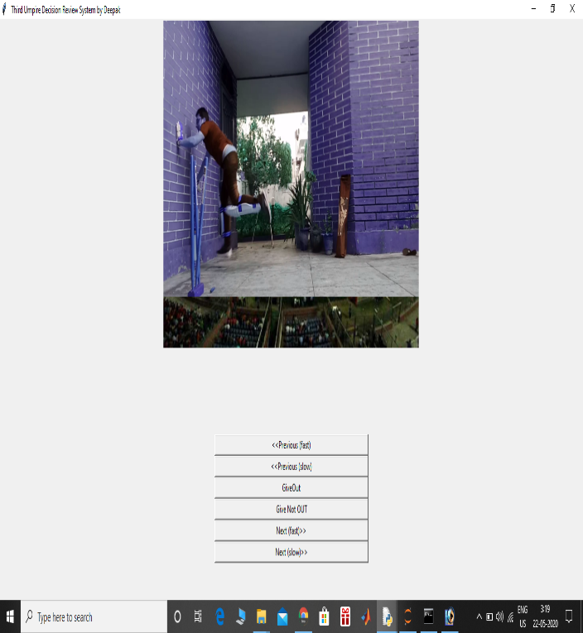

**Slow 5 Slow6**

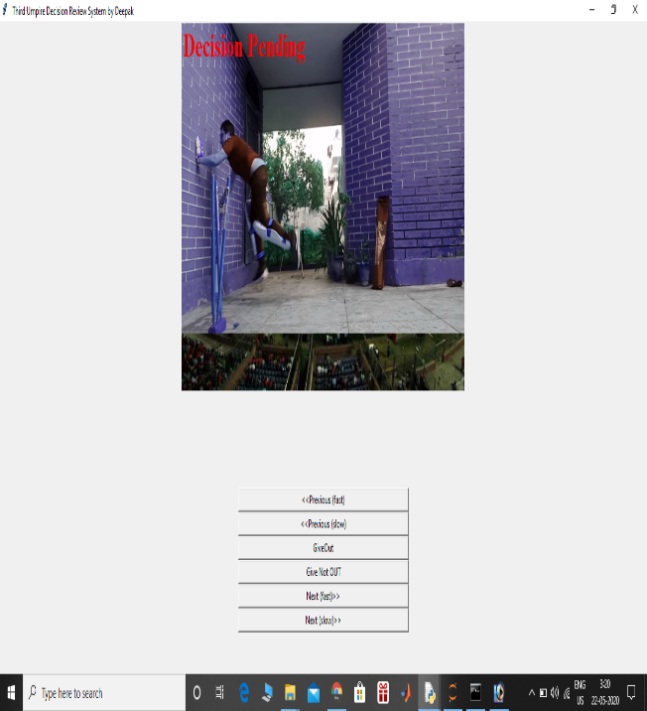 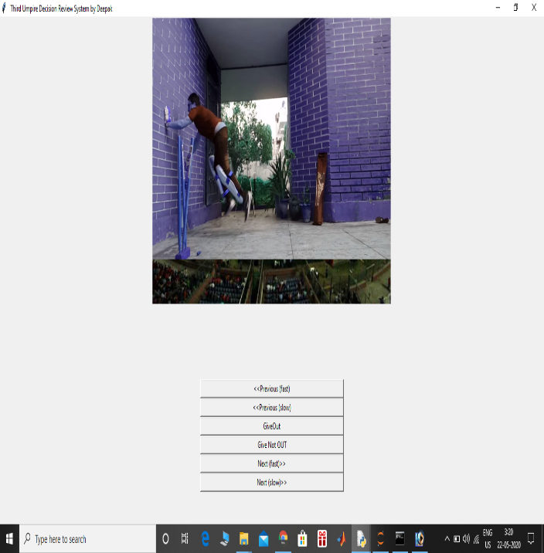

**Slow 7**

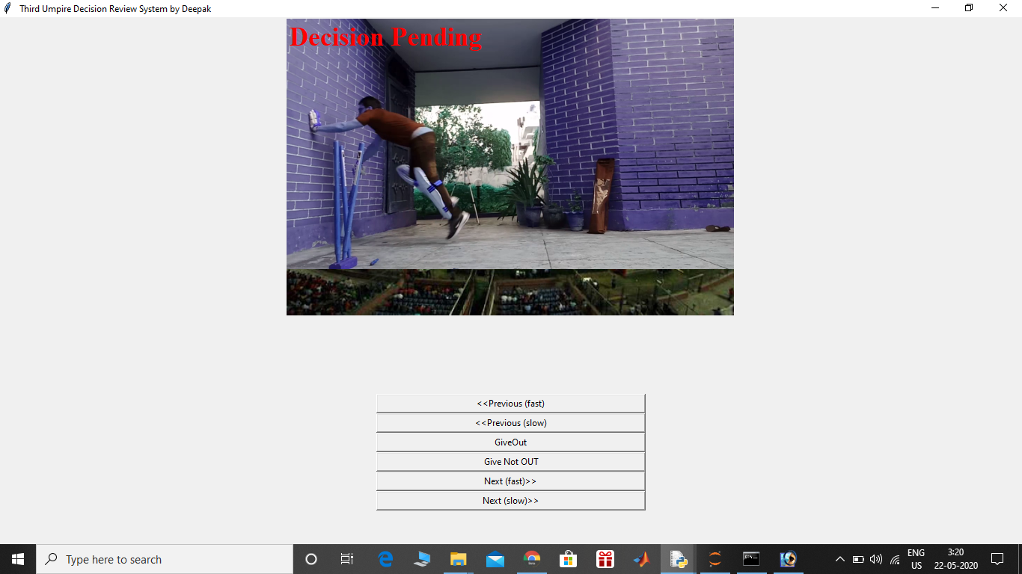

**So in this you can see how slowly we are going back in video.**

**Now after watching all the angles umpire has to make a decision whether it is Out or Not Out. From All the frames its quite clear that Batsman was inside crease before the bails come off.. So its quite obvious that Umpire decision will be Not Out so we have to see on the screen.**

**There will be three things on screen  
1. Decision Pending Sign**

**2. Sponsers(MSIT)**

**3. Decision of UMPIRE**

**DECISION PENDING**

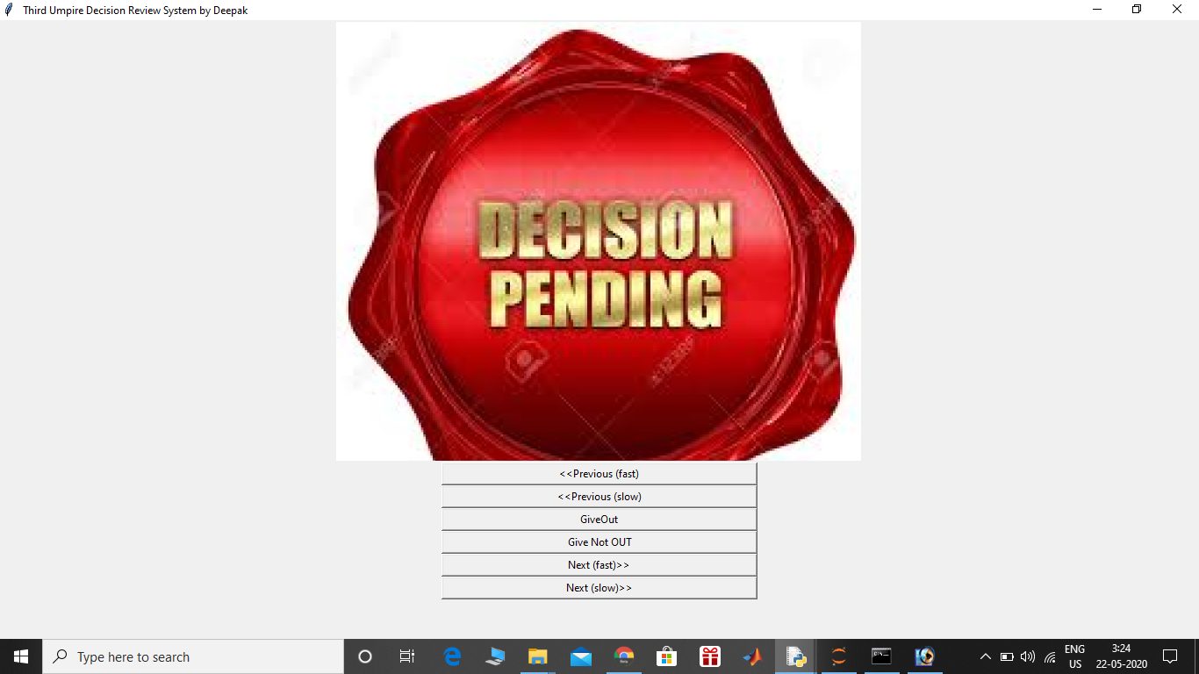

**OUR SPONSERS**

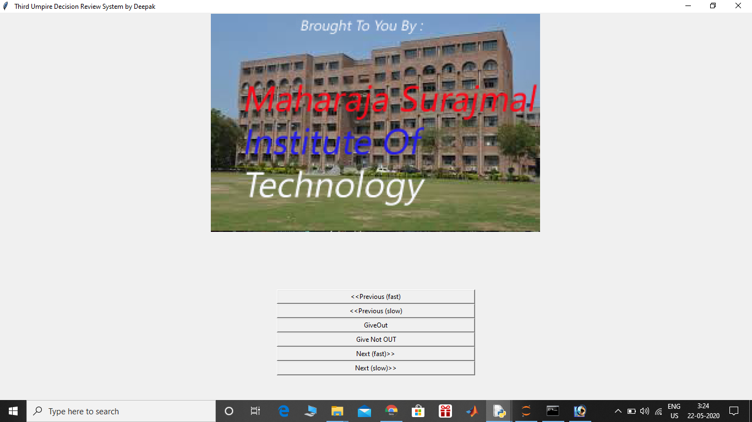

**UMPIRE’S DECISION**

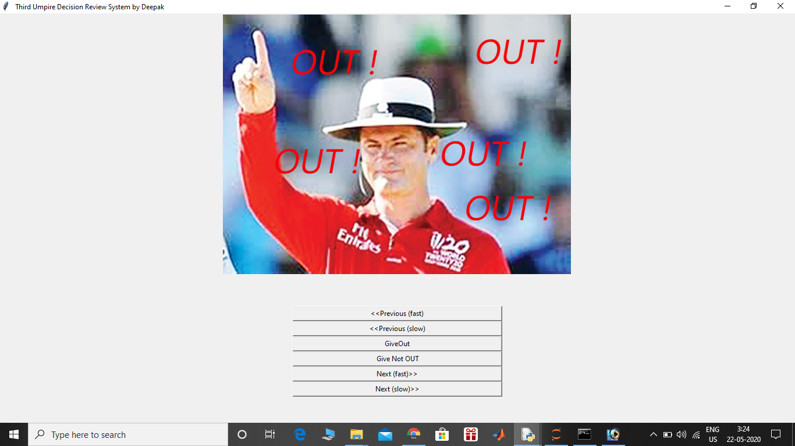

**Ohh Whats that??.. It was a Clear not out yet Umpire raised his figures. Whats wrong there.**

**Umpires are discussing something. Ohh it seems like Third Umpire had pressed the wrong button. Players waiting for right decision.  
Decision Pending is now right there on screens**

**Decision Pending**



**OUR SPONSERS  
**

**UMPIRE’S FINAL DECISION**

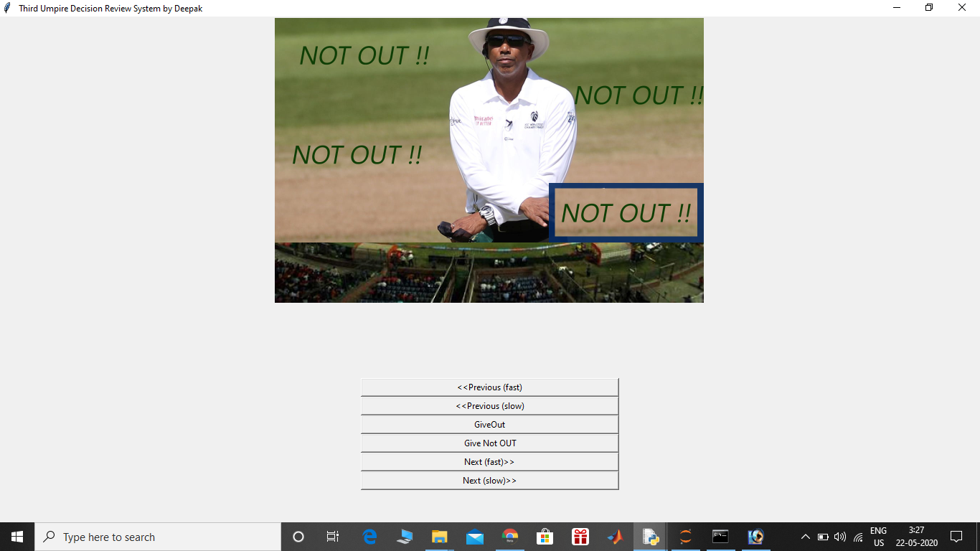

**That’s IT….**

**So this is the final decision by Umpire that batsman is NOT OUT and will continue its innings.**

**DRS method yet proved to be something that one can rely on.**